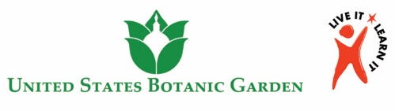Pre- and Post-Lesson Facilitation Guide Overview

The purpose of this guide is to help you facilitate the pre- and post-lessons for your upcoming trip to the U.S. Botanic Garden. This curriculum is designed for easy use. This guide includes:

* Tips about certain questions to ask or content to cover
* Tips for facilitating the hands-on experiences (if applicable)
* Tips for facilitating the assessment (after you complete the trip)
* Additional tips:
  + Slides contain audio recordings. Be sure to project in “slideshow” mode and enable volume.
  + When Violet asks a question or makes a statement, allow students time to discuss before moving forward.

|  |  |
| --- | --- |
| **Key to Symbols in Slideshows** | |
|  | Click anywhere to move forward |
|  | Each student should write in his/her Botanist's Journal |
|  | Click to play video |
| Click here to proceed | Click directly on this arrow to advance  (you will see http://www.clker.com/cliparts/E/l/b/T/j/S/hand-md.png when you hover over the arrow) |

Timing

Pre-lesson: ≈ 75 min (can be taught in two sessions if desired)

Post-lesson: ≈ 45 min (plus additional teacher time for evaluating assessments)